It’s Time… Our God is calling us to make a difference.
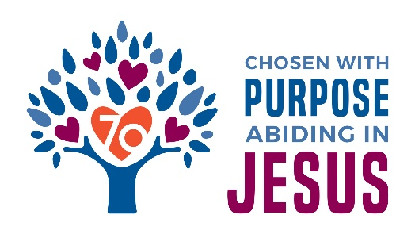
As in 1948, the Florida Georgia District today remains focused on missions - missions that connect people to Jesus. So as we prepare to celebrate God’s blessings for 70 years, it’s only seems right to honor that mission spirit and challenge us to reach out with the saving grace of Jesus to more people, right here in Florida and Georgia.
Just imagine 50 new locations where Jesus and the news of salvation can be proclaimed! That is the goal that has been set, to start 10 new missions (2 in each of the 5 District Regions) each year for the next 5 years.
You will have the opportunity, starting in November, to help achieve this goal. More information about how you can make a difference will be coming in the next few weeks.

