

***(Adult leaders read this devotion aloud. Feel free to change or embellish as you see fit. Several items are in parentheses for your eyes only.)***

***It won't be long now!***

***Before you'll be heading to this year's Middle School Youth Gathering.***

***Once again, the Gathering will be held at the Lake Yale Retreat Center in Leesburg, FL.***

***The theme for this year's Gathering is "SHINE."***

***Over the weekend, you'll make new friends, with plenty of free time to play games, experience new ideas, and learn more about our Lord and Savior, Jesus Christ.***

***So, let's begin with a brief devotion to prepare you for this year's Gathering.***

***\*\*\*\*\*\*\*\*\****

***(Adult leaders, depending on the size of your group, purchase several Trick or Magic candles that won't blow out or relight themselves. Stand them up by inserting them in a cupcake. When you light the candles, please don't allow the student to get too close or hold them, so there's no burnt fingers or faces.)***

***As I mentioned earlier, the theme for this year's Gathering is "SHINE."***

***The Bible verse that will be used throughout the Gathering is:***

***"The light shines in the darkness."***

***John 1:5***



***I'm going to light several candles. I'm going to ask each of you to try to blow one of the candles out from a couple of feet away.***

***(Let the students take turns trying to blow the candles out. Of course, there's always one student who will figure out a way to blow one out, but they'll get the point of this exercise.)***

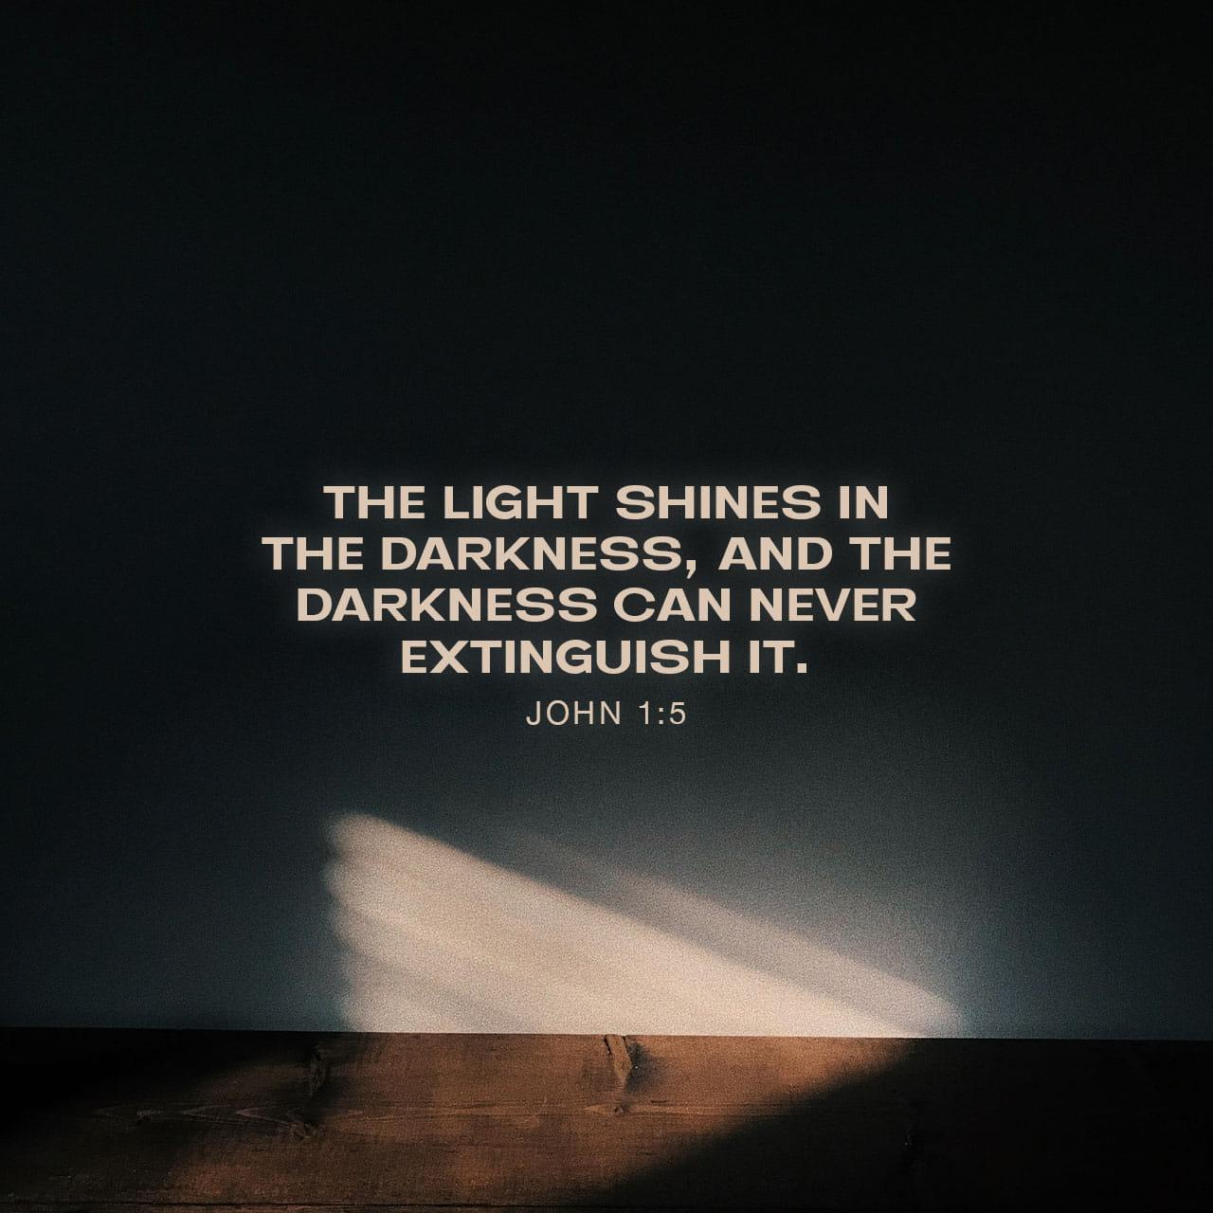

***As you've already figured out, these are trick or magic candles that are made in a way that they relight themselves.***

***How did you feel when you couldn't blow the candle out?***

***(Accept all answers)***

***"What is some of the darkness we experience in this world?"***

***(Again, accept any and all answers. Some of the answers you're looking for are" Crime, hate, prejudice, cheating, lying, and the darkness we sometimes feel inside when we're mad, or sad, or filled with anger and allow the students time to discuss.)***

***Biblically, when we talk about "light," who are we talking about?***

***(Jesus)***

***Okay, so what is "Darkness?"***

***(Darkness is our sinful and fallen nature)***

***Know this. Darkness cannot overcome the light that Jesus brought into the world. He lived, suffered, and died for our sins (darkness).***

***During the Gathering, you'll hear speakers and some great music and attend experiential workshops that will discuss:***

***Jesus as our source of light!***

***Listen, learn, share, and pray.***

***Let's pray!***

***Lord, we are getting ready to attend this year's Gathering. Please help us experience it all. Let there be fun and fellowship with others. Most of all, let our ears listen, and our hearts understand the message that Jesus is the light of the world.***

***Amen!***